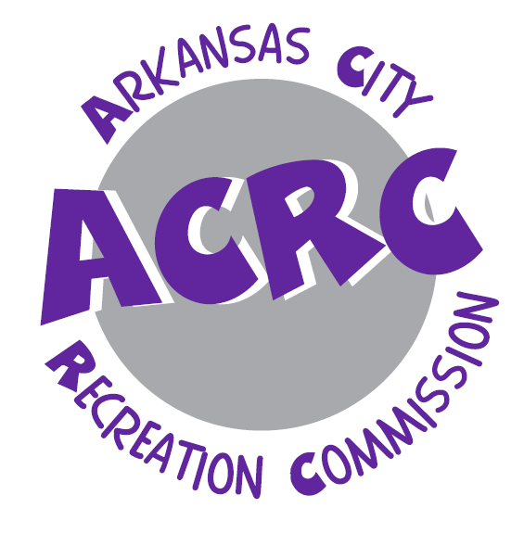
Kidz Club Guidlines

Ark City Kidz Club Guidelines
📢 New Childcare Services at the Rec Center!
The Arkansas City Recreation Commission (ACRC) is excited to introduce Ark City Kidz Club (ACKC) — a childcare service designed to help parents enjoy our fitness and wellness opportunities without worrying about childcare.
ACKC is open to children ages 3 months to 8 years. This service is available to parents who are participating in ACRC Fitness Center memberships, fitness classes, walking track, or open basketball.
Important: Parents must remain on-site at the ACRC facility (225 E. 5th Ave., Arkansas City, KS) while their child is in ACKC. Please note that ACKC is not a licensed childcare facility. In accordance with state guidelines, each child may use the service for a maximum of 1.5 hours per day.

Registration
- Register online: arkcityrec.recdesk.com
- Or register and pay in person at the ACRC office.

Hours of Operation
- Monday–Friday: 9:00 – 10:30 AM
- Monday–Thursday: 4:45 – 6:30 PM

Fees
- Preregistered – Monthly: $20 daily use (1.5 hr max/day),
- $15 for each additional child.
- Drop-in Rate: $5 per day (1.5 hr max/day). Drop-ins are not guaranteed and depend on capacity.
➡️ Note: Preregistered children are always guaranteed a spot. Drop-ins are accepted only if staff-to-child ratios allow.

Guidelines
- Time Limits:
  - Ages 6 weeks – 3 years: up to 1 hour per visit
  - Ages 4 – 8 years: up to 1.5 hours per visit
- Parent/Guardian Requirements:
  - Must remain at the ACRC facility at all times.
  - For infants under 6 months, parents must bring a portable carrier.
- Health & Safety:
  - Children must be fever-free for 24 hours before attending.
  - If your child has vomiting, diarrhea, or severe coughing, please keep them home.
  - If your child is on antibiotics, they may return 24 hours after starting medication.
- Meals & Drinks:
  - Please feed your child before arrival.
  - Drinks with lids are allowed (labeled with the child’s name).
  - Snacks are not permitted due to allergies.
- Personal Items:
  - Toys are provided, but personal toys may be brought if safe for all children.
  - Parents must provide diapers, wipes, and a diaper bag for non-potty-trained children.
- Behavior:
  - Discipline will be handled with time-outs only.
  - If a child cries for more than 10 minutes, parents will be asked to return.
- Check-In/Check-Out:
  - Parents must sign children in and out.
  - Each parent/child will receive matching ID numbers and bracelets, which must be presented at pick-up.

Health & Emergencies
- All staff are American Red Cross certified in First Aid/CPR.
- We do not provide medical or nursing staff.
- Minor injuries will be treated with first aid and reported at pick-up.
- Serious injuries: 911 will be called immediately, parents will be notified, and a staff member will accompany the child to the hospital until the parent arrives.
- In case of illness or emergency, the parent/guardian who signed in will be contacted first, followed by the listed emergency contact.

Waiver of Liability
All participants must sign an ACRC liability waiver. This waiver releases ACRC, its staff, volunteers, and affiliates from liability in case of injury, accident, or other circumstances.

Photos
Photos may occasionally be taken during Kidz Club for department use only (marketing, brochures, or promotions).

✨ Ark City Kidz Club is here to help parents stay active while knowing their children are safe and cared for nearby.

