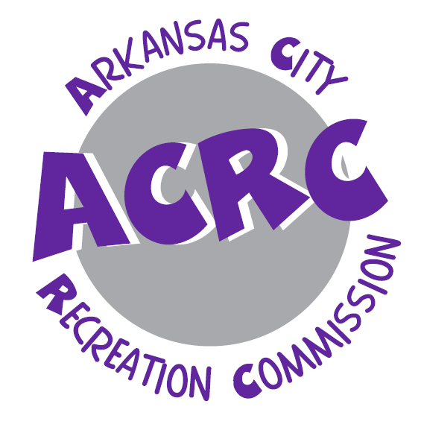

Parent guidebook

IYQ Day Camp

2026
Arkansas city recreation commission
(620) 441-4300
Introduction
We are thrilled that your camper will be joining us this summer and we want to welcome you to IYQ Day Camp! We know that your children are the most precious things in the world to you and we want to thank you for trusting us to spend the day, week, or entire summer with them! Our goal is to provide a fun, relaxing, and safe environment that all children can enjoy, regardless of age or ability. Although each child is a unique individual, we believe summer camp is beneficial for all kids. No matter your child’s interests are, camp helps children develop important social, emotional and cognitive skills Best of all, children create memories that last a lifetime at camp. This booklet will tell you everything you need to know about this summer’s camp. IYQ Camp is designed to make your camper’s summer experience fun, happy, exciting, and worthwhile. If you have any questions or require more information, feel free to give us a call at 620-441-4300 Arkansas City Recreation Center.

Registration
To register for IYQ Day Camp, you may use our on line registration by visiting: arkcityrec.recdesk.com. Or you may visit the Arkansas City Recreation Commission to register and pay in person.

Sessions
Session #1 | June 1-4
Session #2 | June 8-11
Session #3 | June 15-18
Session #4 | June 22-25
Off Week | June 29- July 2
Session #5 | July 6-9
Session #6 | July 13-16
Session #7 | July 20-23
Session #8 July 27-30

Payment
Payments may be made at IYQ Camp in the form of Cash, Checks or Card. Cost per session is $40 and is due the Thursday before the start of each session. Swim lessons are offered at Paris Park Pool during all sessions for an additional cost of $15. We also offer an early bird drop off starting at 8:00am for additional cost of $10.
Please be mindful of registration deadlines
There will be an opportunity to register on-site each Thursday before leaving Camp; this allows us to prepare for the following week. For your child’s greatest success with our program a $10 fee will be imposed on all our programs after registration date has ended. This will ensure that we have adequate counselors, supervision, supplies, and uniforms.
Camp Information

Communications
We will always call you if we feel it is important. Please feel free to do the same. Of, course, there are some non-serious, non-threatening situations in which we will not notify you (applying a Band-Aid for small scrapes), but you can be assured that we will use our best judgment to decide when to notify you. A cell phone for the Camp Director is on site at all times if needed. You can reach AJ Davidson by calling (620) 660-1878.

Concerns
If any concerns arise, please feel free to contact the Camp Director or Site Supervisor.

Grouping
Campers are grouped together by age. We keep a Counselor to Camper ratio that allows adequate supervision of children at all times. This helps to ensure the inclusion and safety of all campers while participating in activities. Once groups have been assigned, we ask your help by not asking children to be moved to another group unless you have a concern. Having campers meet new campers is one of our program goals. The age groups are as follows:
4-5 Year olds 9 Year olds
6-7 Year olds 10 Year olds and up
8 Year olds

Daily Schedule
Early Bird Session 8:00-9:15am requires add on fee of $10.00
Drop-off | 9:15-9:30am (Please no early arrivals)
Activity #1 | 9:30-9:50am
Activity #2 | 9:55-10:15am
Activity #3 | 10:20-10:40am
Activity #4  Activity #5  Stations  Swim Lesson Lunch | 10:45-11:05am  11:10-11:30am  11:30-11:50am  11:30-11:50am
Lunch and Change for Pool | 11:50-12:45pm
Pool | 1:00-2:50pm
Snack at Pool  Leave the Pool | 2:50-3:00pm  3:00pm
Change | 3:05-3:20pm
*Pick-Up | 3:30pm
*We ask you to pick up your Camper by entering the pick-up area vs them going to parking lot alone. If for some reason, another person will be picking up your child, please make us aware of such and make sure they are on the approved pick-up portion of your information sheet.
Add ons:
Early Bird Session additional $10
We try our best to accommodate families schedules in every way possible. It has come to our attention there is a need for campers to be dropped off at camp before 9:15 AM. We have created an Early Bird Session beginning at 8:00 AM. Doors will not open before 8:00am. Campers may arrive at this time. They will be given breakfast and activities to fill the time until 9:30 AM when camp begins. There will be a small add on fee of $10.00 per week, per child to cover the cost of Team members to supervise the campers and activities. Campers dropped off before the 9:15 AM start time will need to be enrolled in the Early Bird Session.
Swim Lesson additional $15
We offer swim lessons to Levels 1-6 during their lunch hour. The swim lessons children will eat first, change then go to swim lessons while the other children are eating. Lessons are from 12:15-12:50pm at the Paris Park Pool. Then they will reunite with their group before going to the pool.

Weather and Other Emergencies
In case of extreme weather, the campers will be taken to the FEMA Shelter at Frances Willard School located at 201 North 4th Street. In the event of sirens going off and the weather is of severe nature, we encourage you to join us in the FEMA safe shelter vs taking children out into a potentially dangerous situation. We take the responsibility of your child very seriously. When rain does not allow us to visit the pool, we will have fun and exciting indoor activities for your Camper.

Camp Policies

Waiver of Liability
All of our Programs include a liability waiver, It states:
It is hereby acknowledged that the undersigned and the registered participant will abide by the rules and regulations of the ACRC and the above specified association or program sponsor. In case of injury, death or circumstance, and in consideration of acceptance into the program, the undersigned, the registered participant, and their respective heirs, administrators, executors, or assigns, hereby release, absolve, indemnify and hold harmless the ACRC, its subsidiary organizations and their officers, agents, employees, volunteers, and/or other participants.

Emergency Contacts
The name of the parent/guardian that signed the camper up for camp will be the first person we call in case of an emergency unless otherwise noted. If you wish to list another or change the emergency contact, the parent/guardian that signed the camper up may change it at any time.

Illness
If your child is running a fever, vomiting, has diarrhea, or severe coughing, your child should not be at day camp to avoid the risk of getting other children sick as well. If your child has another illness that requires an antibiotic, they may return to camp 24 hours after starting their antibiotic. If the child is too ill to take part in usual activities then we suggest keeping the child home as well.

IYQ Camp is not designed to support any major medical needs. All Camp staff are certified through the American Red Cross in First Aid/CPR, but we do NOT staff any medical or nursing staff. If an injury is minor, first aid will be done and reported to the parent at the end of the day with pick up. If the injury is life-threatening or very serious, 911 will be called and camper will be transported to the hospital via EMS. Parent will be notified immediately and Camp Director will go to the hospital with Camper until parent arrives.

Medication
All Medications brought to camp MUST be checked in to the Camp Director or Site Supervisor.
If your child is on any medication that they would need to take while at camp, it must be in its original container with the medication, dosage, name of the child, and phone number. A form must also be filled out stating that the medication may be administered to the child by the Site Supervisor or Program Director. Children are NOT permitted to bring the medication with them.

Photos
Please be aware photos may be taken during IYQ Camp for department use only and may be used for future marketing and brochure purposes.

Code of Conduct

Camper Behavior
All campers are expected to behave in a respectful way to counselors and other campers. This includes keeping hands to themselves unless they are playing a game that permits it, like tag, patty cake, etc. There is a zero tolerance policy for foul language and bullying at IYQ for both campers and counselors.

Discipline Policy
We operate on a 3 Strike Philosophy. Unacceptable or disruptive behavior will result in the child receiving a “timeout” until acceptable behavior is restored. The child will be informed of the reasons they are being disciplined as well as suggestions as to alternative and appropriate ways of behaving. The second time the child misbehaves a parent will be notified. The third discipline referral may result in the child being removed from the program.

Drop-off/Pick-up
Only the person(s) designated on the program information form will be permitted to drop-off/pick-up campers from camp. Names may be added or removed by the parent/guardian only. Requests must be in writing and signed by the parent/guardian who signed the original program information form. We reserve the right to request that you show a photo ID when picking up campers.

What to Bring
Campers should wear athletic clothing to camp as they will be doing a lot of movement in some of their activities. Campers should also bring a bathing suit and towel. If you would like to send a few dollars with your child so that they can buy a drink or snack at the pool concession stand you may but it is not necessary. Most concessions items are between .50 and $2.50.

Parent Checklist
- Please DO NOT allow child to bring cell phones, Apple watches, ear buds, electronic devices or toys to camp, as well as expensive clothing or shoes. If you need to communicate with your child during camp time, please make arrangements to do so through our Camp Cell Phone.
- Please check any bags your child brings to camp to ensure contents are appropriate for camp.
Before going to swimming pool rotation, each camper is covered with sunscreen by their counselor. We ask you to help us by applying sunscreen prior to camp for morning activities. We ask each child to bring a swimsuit and towel and it is helpful for them to be marked with the child’s name.
We have planned a lot of great activities and crafts for the campers and hope this to be the greatest time ever at IYQ. Thank you in advance for allowing us to be a part of your child’s summer.

